

fi

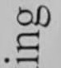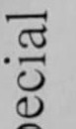

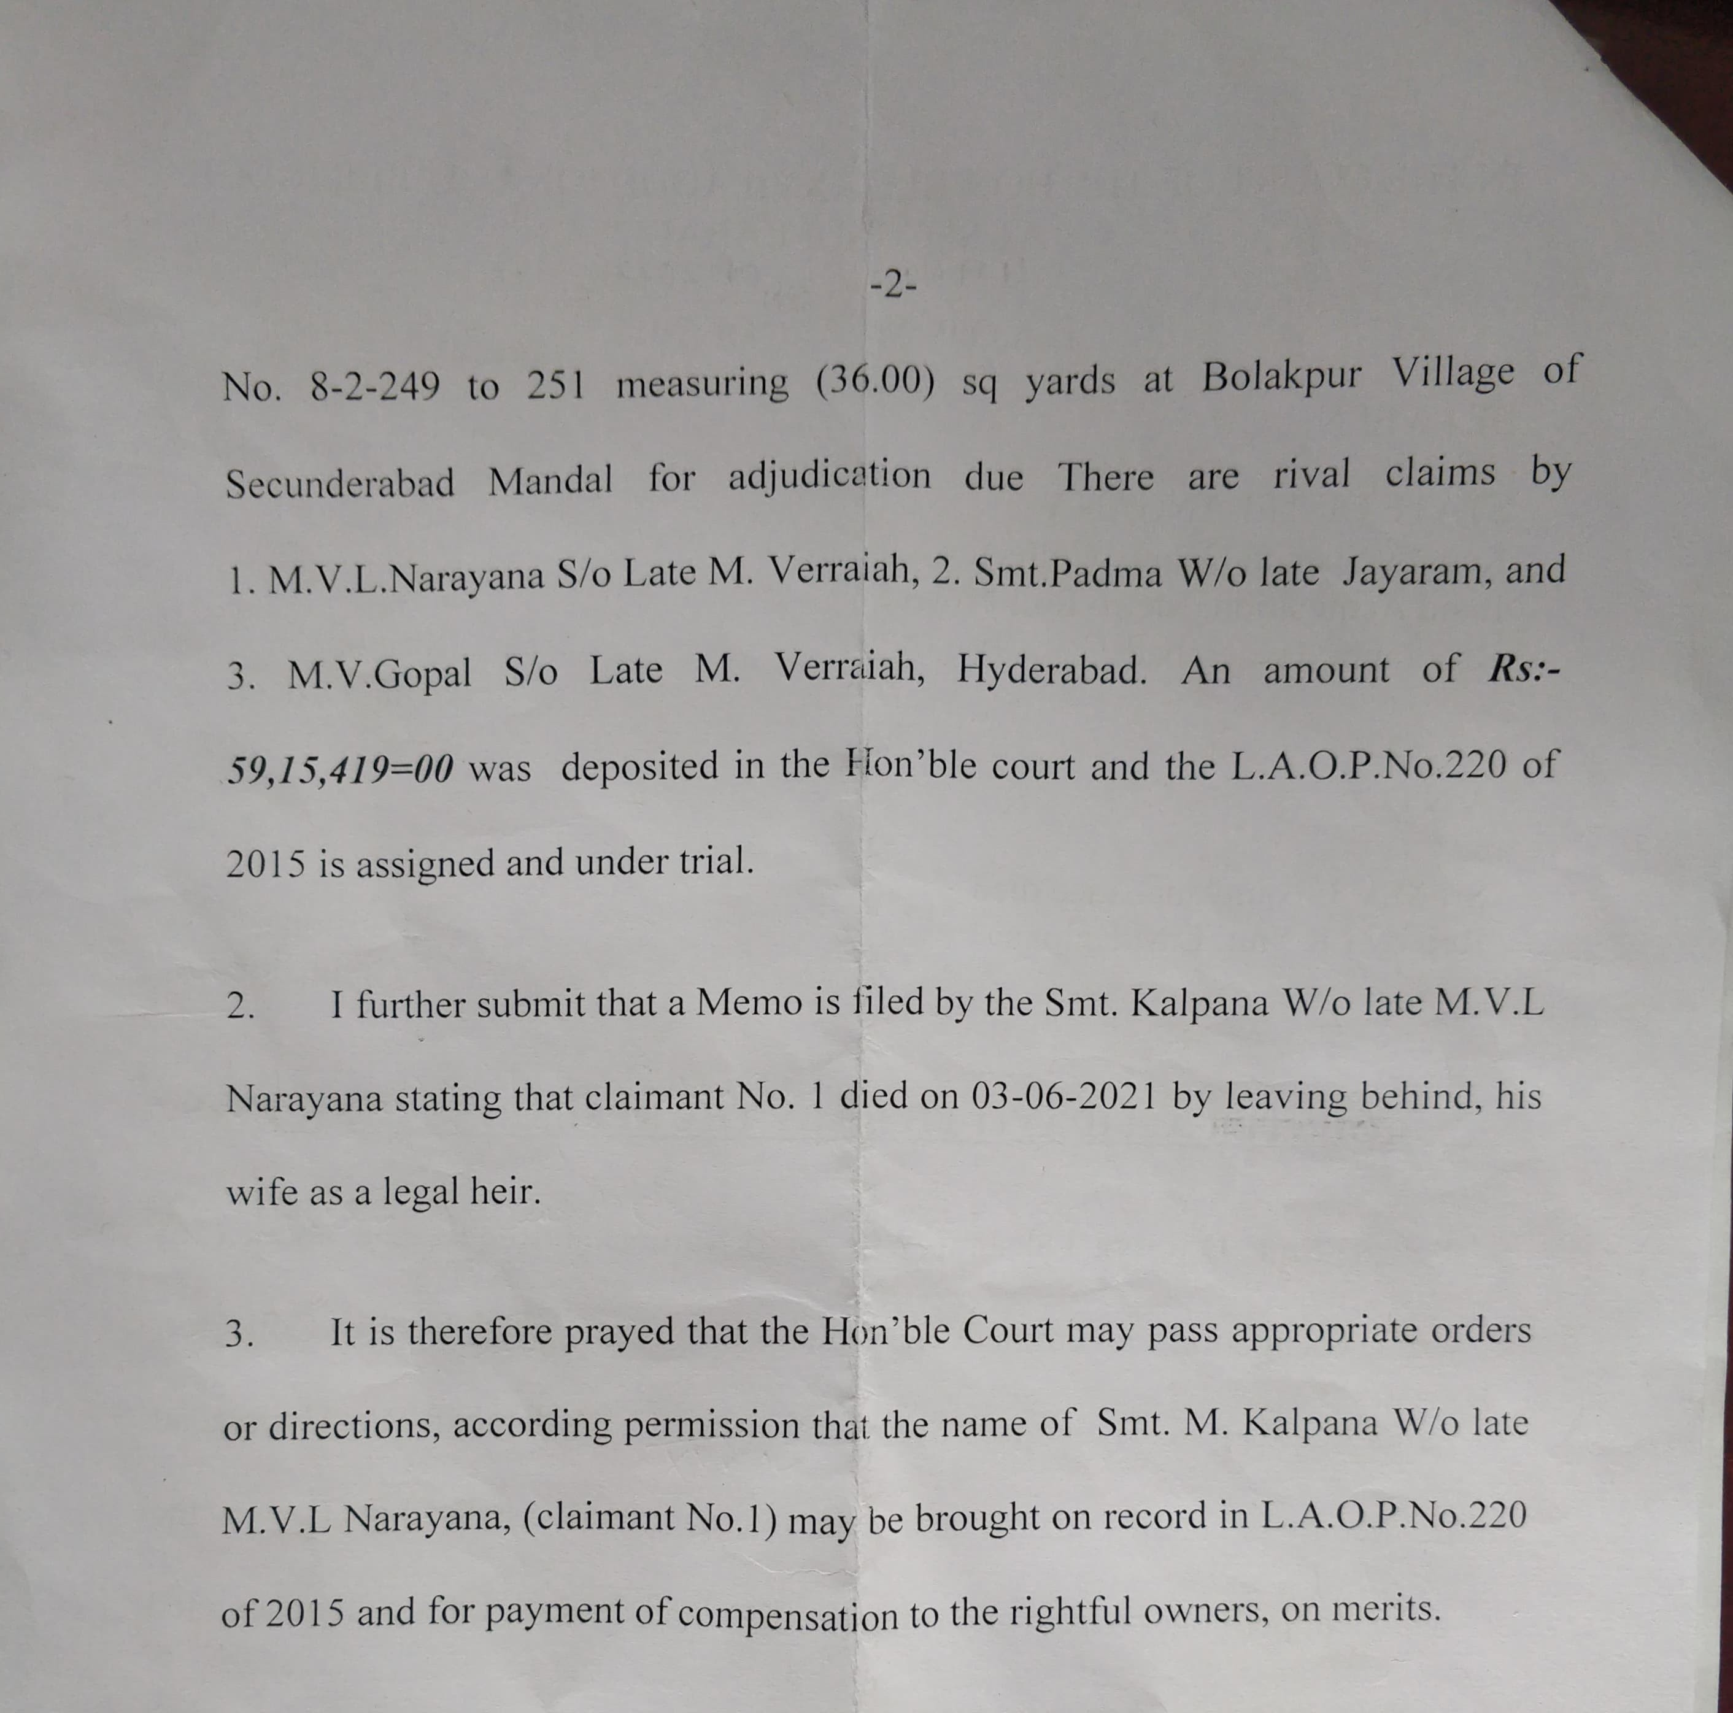

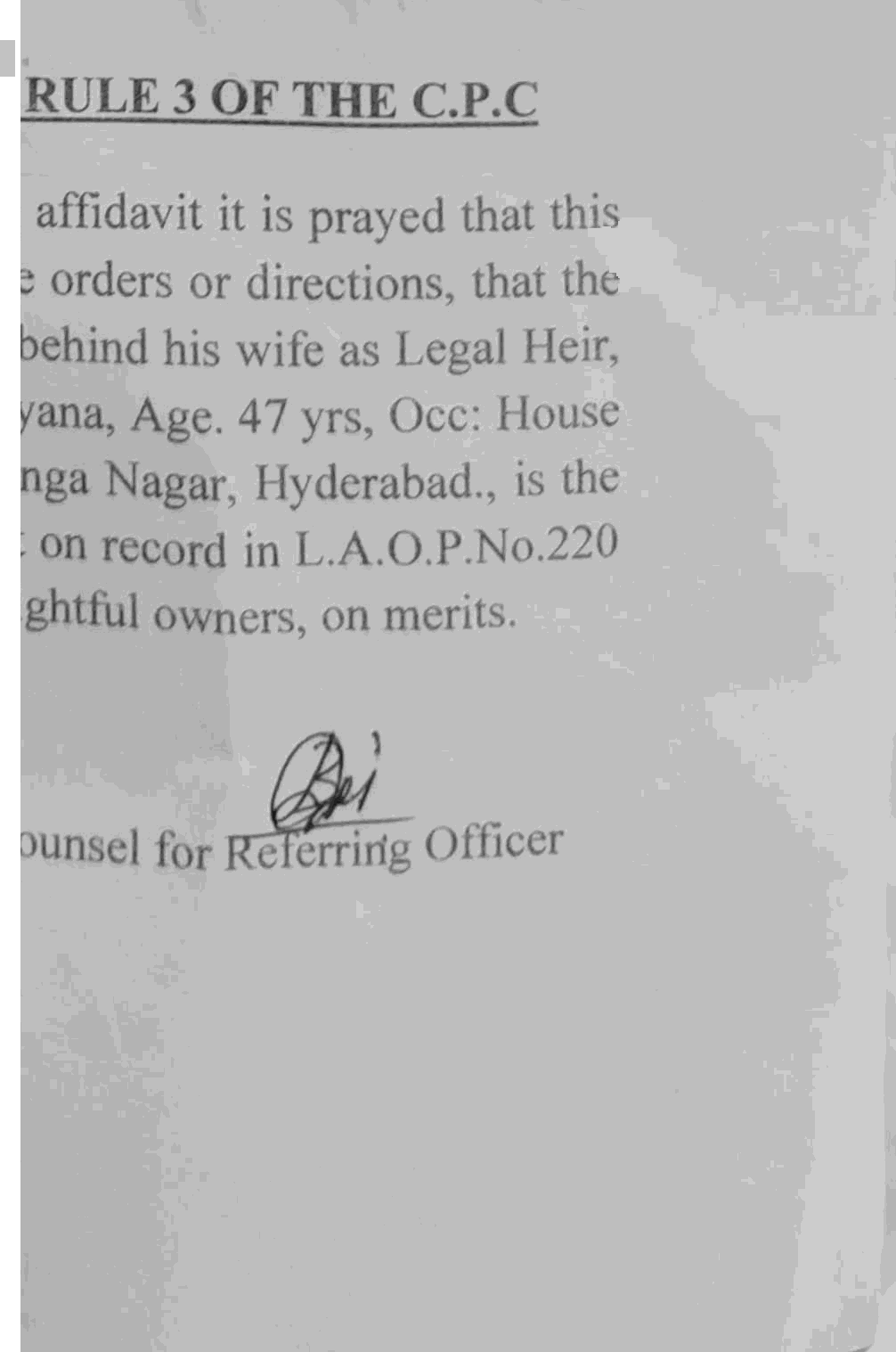

r



* _ ‹..

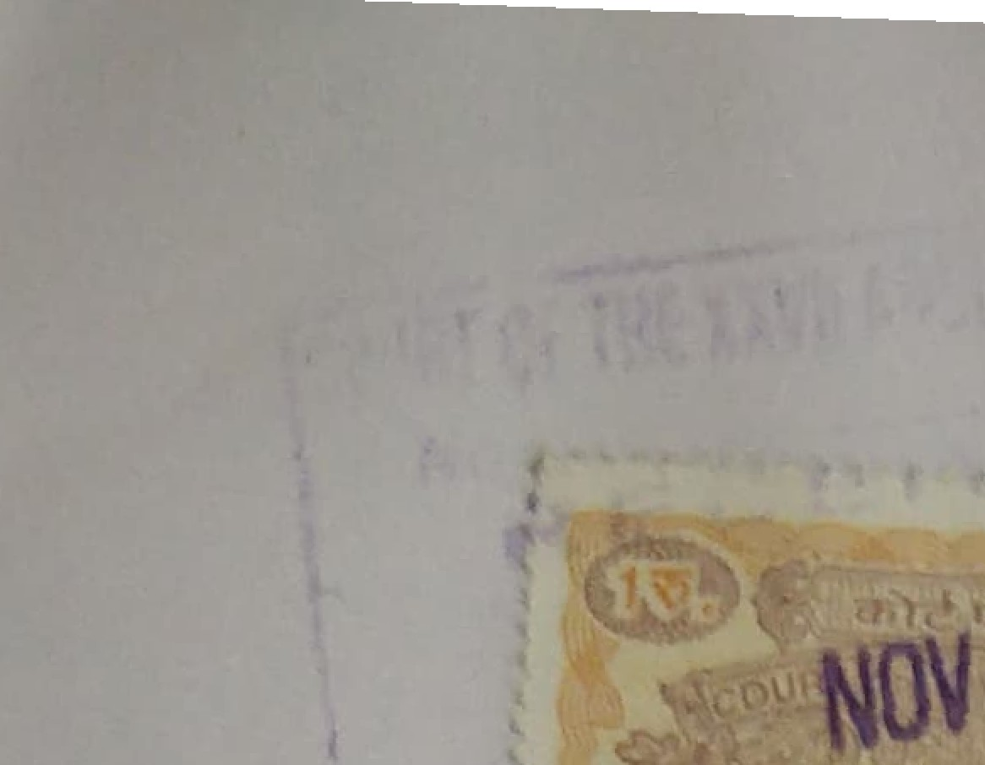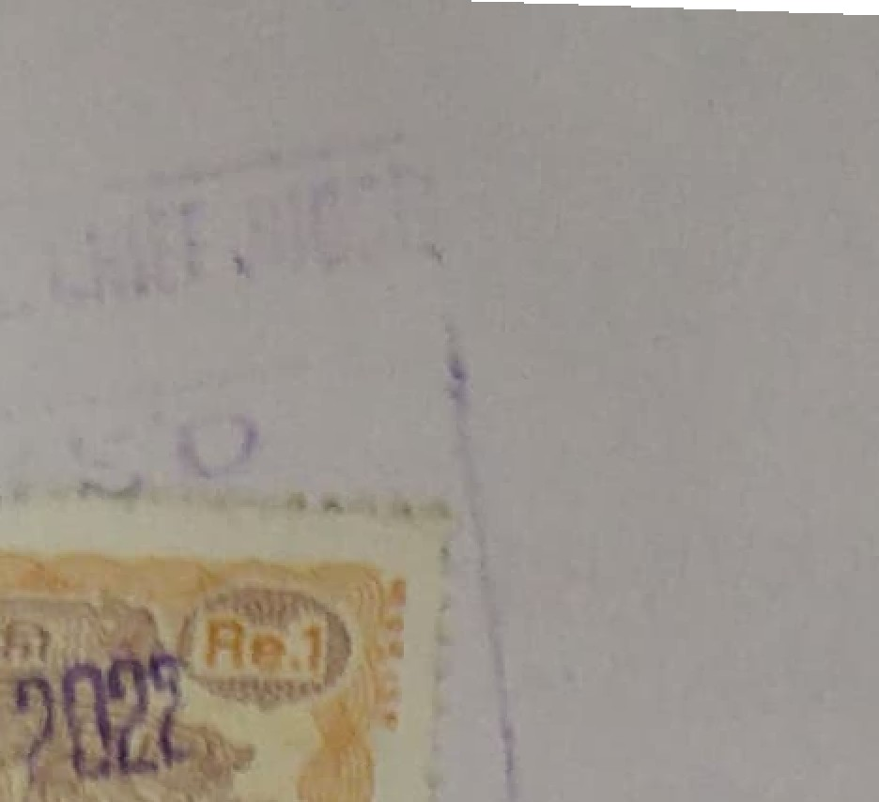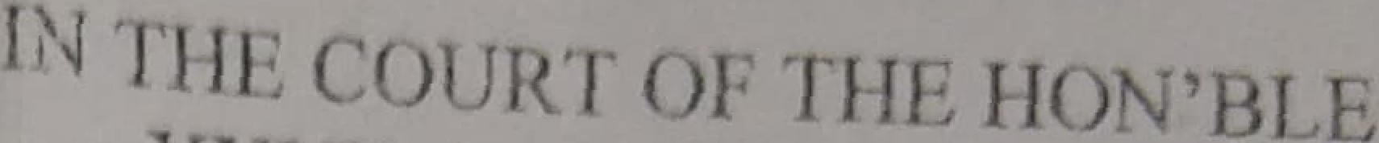

Addl, Clg$5 Jjjjg¿;p

4T S£C1D Ejt,qg,gg,

* 1. 7\.No.

# P r›ject, Hyderabad.

OF 20 2

# ..Petitioner/



Sri. MVL Narayan a

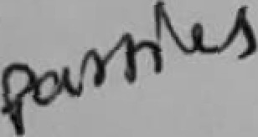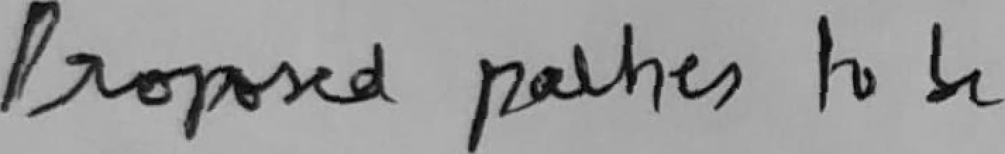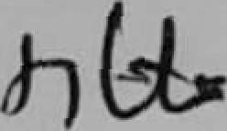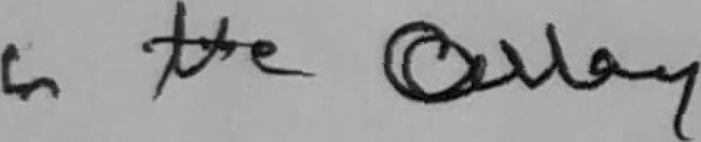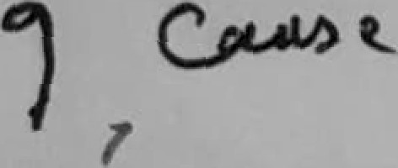

***

?'nce died per OR & Others

.Respondents/

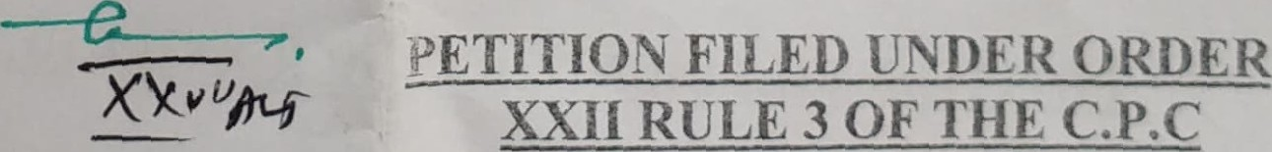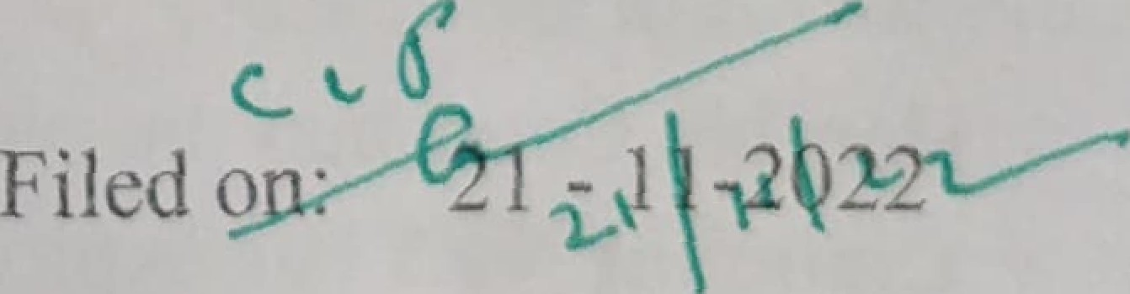Claimants

Filed by: C oufl$el fOF Spl.D; . C‹›llccior Lancl Acquisition f)tl"iccr



C it› £ li’i1 C ‹)urls. iie*’had

